Moderation layer integration with test case generator: test case generation blocked, toast message displayed as PII data was present
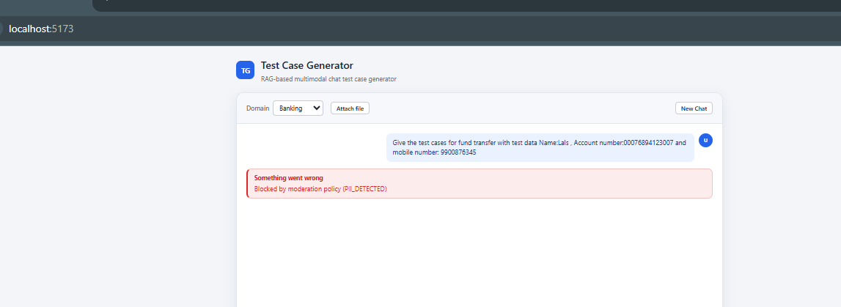

Test case generation allowed with Masked data. Toast message informs the user CII detected and hence masking:
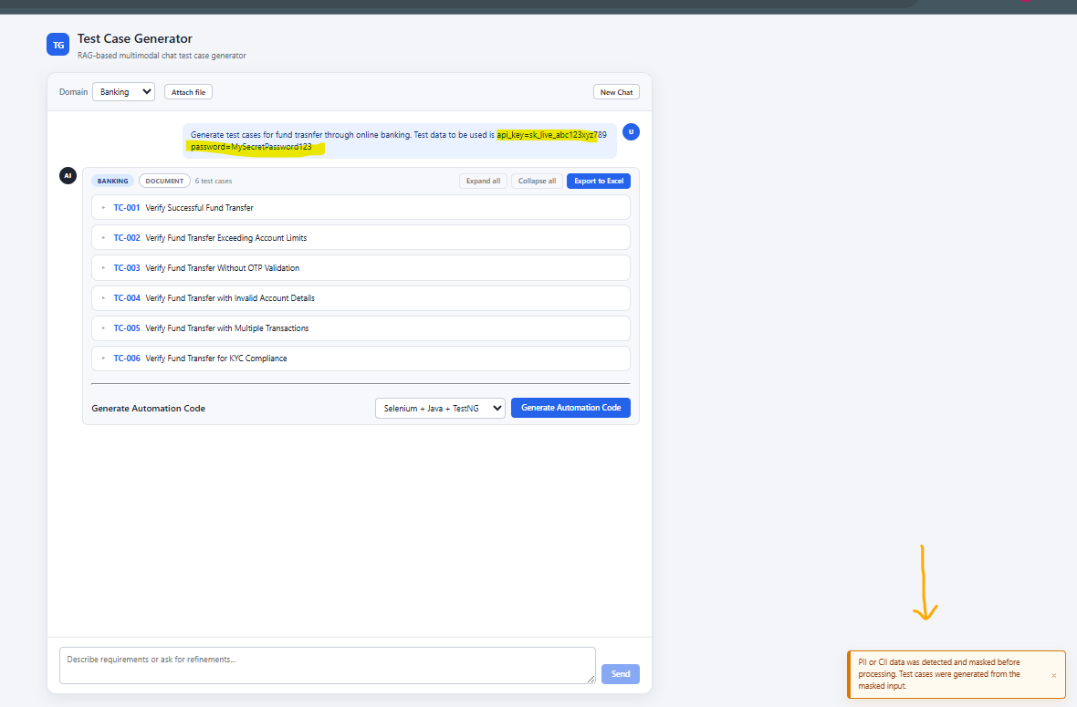
Test case generation successful as no PII or CII was detected.
